**AGGREGATION FUNCTIONS**

**1)Display Maximum salary from employee table whose name contain ‘i’ & date of joining is ‘1-12-2024’ (use alise)**

**🡪SELECT MAX(salary) as salmax FROM oit as employee WHERE ename LIKE '%i%' and date_of_joining='13/7/2024';**

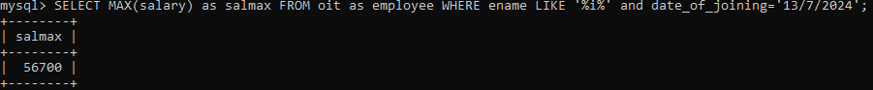

**2)** **Count the total no of employee whose belong to place ‘pune’ or satara city and designation is ‘MANAGER’**

**🡪 SELECT COUNT(ENO) AS ENOCOUNT FROM OIT AS EMPLOYEE WHERE CITY IN('PUNE','SATARA') AND DESIGNATION=' MANAGER';**

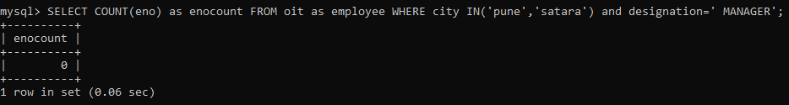

**GROUP BY**

**1)Count total number of employee designation wise mysql>**

**🡪SELECT COUNT(eno) as Total_emp,designation FROM oit GROUP BY(designation);**

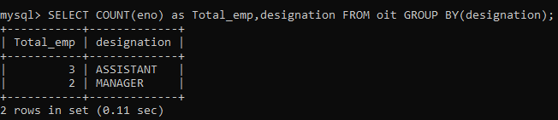

**2) Count maximum salary of an employee city wise**

**🡪SELECT Max(salary) as Max_Salary, city FROM oit GROUP BY(city);**

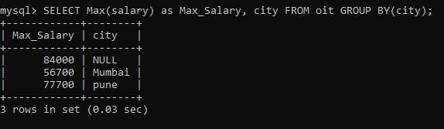

**3) To find total salary value of employee citywise having salary>50000**

**🡪 SELECT SUM(salary) as Sum_of_Salary, city FROM oit GROUP BY(city) HAVING sum_of_salary>50000;**

